***Documentation***

**Title: Software Freedom Kosova Conference - SFK 2020**

**Project description:**

Software Freedom Kosova 2020 was an online conference held on September 26-27, 2020, focused on the theme "Sensors for Good." The event provided a collaborative space for sharing knowledge in open technology, featuring 22 sessions, including workshops, talks, and a discussion panel. The conference aimed to explore the use of sensors and their applications in technology while promoting open-source principles.

**Activities:**Key activities:

* Hosted 22 sessions, including 7 workshops and 15 talks.
* Live-streamed the conference through the official website, YouTube, and Facebook.
* Organized promotional campaigns across social media, reaching over 15,000 users.
* Delivered key presentations on open-source adoption and sensor-related technologies.

**Photos:**

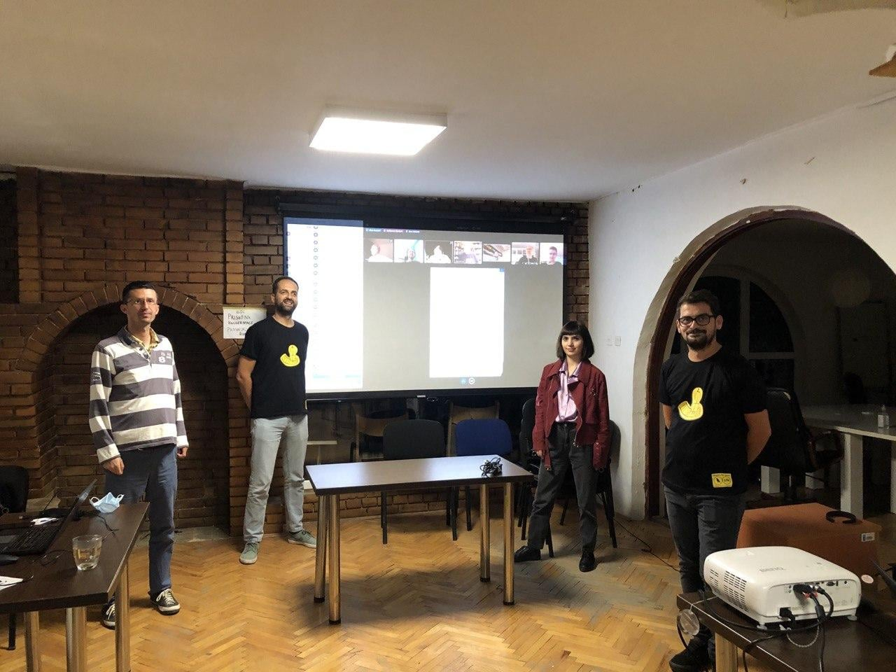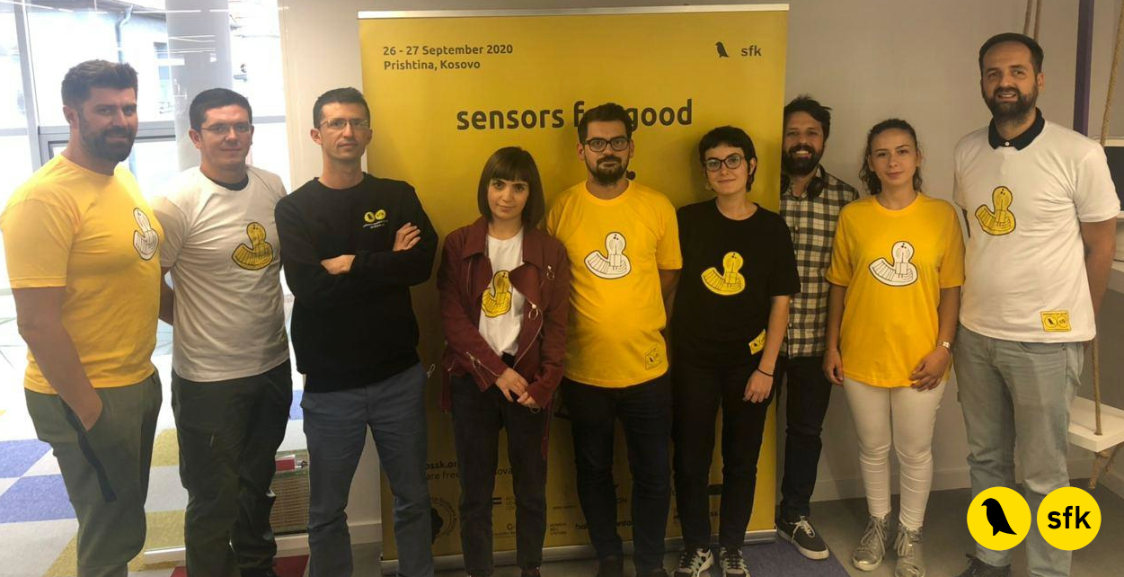

**Beneficiaries:**

The conference primarily benefited students, technologists, and professionals in software and hardware development. It provided insights into modern technologies, including ExpressJS, NodeJS, Internet of Things, and Wikipedia editing.

**Partners:**

* Austrian Development Agency
* Skins Agency
* Frakton
* Gjirafa Inc.
* Swiss Entrepreneurial Program
* Empower Engage Build Ownership Project

**Budget:  
€17,865.00**

**Project duration**:

May 4, 2020 – September 30, 2020

*This document is FLOSSK intellectual property - Do not share without authorization from FLOSSK.*